# SYNOPSIS

**Report on Project Allotment System**

**by**

Dhairya Kathuria 2100290140058

Nakul Singh 2100290140094

Vedant Gotra 2100290140153

# Session:2022-2023 (4th Semester)

Under the supervision of

# Miss Shalika Arora (Assistant Professor)

**KIET Group of Institutions, Delhi-NCR, Ghaziabad**



**DEPARTMENT OF COMPUTER APPLICATIONS KIET GROUP OF INSTITUTIONS, DELHI-NCR,**

**GHAZIABAD-201206**

(MARCH- 2023)

# ABSTRACT

The project allotment system is a software application designed to automate and optimize the process of project allocation. The system aims to eliminate the manual effort required for project allocation, reduce the chances of errors and biases, and ensure a fair and transparent allocation process.

The project allotment system consists of three primary modules, including the user module, the project module, and the allocation module. The user module maintains the records of all the users, including their skills, interests, and availability. The project module maintains the records of all the available projects, including their requirements, deadlines, and criteria. The allocation module matches the requirements of a project with the skills and interests of potential users to suggest the most suitable users for the project.

The project allotment system offers numerous benefits, including increased efficiency, reduced manual effort, improved transparency, and valuable insights into project allocation patterns. It is an excellent tool for organizations, educational institutions, and research centres looking to optimize their project allocation process and ensure fair and equal opportunities for all users.

Overall, the project allotment system provides a reliable and efficient solution to the complex task of project allocation, enabling project supervisors to allocate projects quickly and fairly, while ensuring that users are matched with projects that best suit their skills and interests.

**Keywords:** Easy allotment, Easy supervision, Equal opportunity.

# TABLE OF CONTENTS

1. Introduction 4
2. Literature Review 5
3. Project / Research Objective 6
4. Research Methodology 7
5. Project / Research Outcome 9
6. Proposed Time Duration 10

References 11

**Introduction**

The project allotment system is a software application designed to automate and streamline the process of project allocation. In organizations, educational institutions, and research centers, it is often necessary to allocate projects to students or employees based on their skills, interests, and availability. This can be a time-consuming and challenging task for project supervisors, especially when dealing with many users and projects.

The project allotment system aims to simplify this process by providing an automated solution that matches the requirements of a project with the skills and interests of potential users. It eliminates the need for manual effort, reduces the chances of errors and biases, and ensures a fair and transparent allocation process.

The system consists of three primary modules, including the user module, the project module, and the allocation module. The user module maintains the records of all the users, while the project module maintains the records of all the available projects. The allocation module matches the requirements of a project with the user's skills and interests to suggest the most suitable users for the project.

The project allotment system offers numerous benefits, including increased efficiency, reduced manual effort, improved transparency, and valuable insights into project allocation patterns. It is an excellent tool for organizations, educational institutions, and research canters looking to optimize their project allocation process and ensure fair and equal opportunities for all users.

# Literature Review

A Study on Project Allocation System using Data Mining" by J. Kausalya and P. Sumathi: The authors proposed a project allocation system using data mining techniques such as association rule mining, decision tree, and k-means clustering to match the skills and preferences of students with the requirements of the projects. The system was found to be efficient and effective in allocating projects.

An Intelligent Project Allocation System Using Fuzzy Logic and Genetic Algorithm" by R. Jafarzadeh and A. R. Shahriar: The authors proposed an intelligent project allocation system that uses fuzzy logic and genetic algorithm to allocate projects to students based on their skills and preferences. The system was found to be accurate and efficient in allocating projects.

Optimization of Project Allocation Process using Multi-Criteria Decision-Making Techniques" by S. K. Pandey and S. Goyal: The authors proposed an optimization technique using multi-criteria decision making (MCDM) techniques such as TOPSIS and AHP to allocate projects to students based on their skills and preferences. The technique was found to be efficient and effective in allocating projects.

A Hybrid Intelligent System for Project Allocation" by J. Parthiban and S. Sridharan: The authors proposed a hybrid intelligent system that uses neural network and genetic algorithm to allocate projects to students based on their skills and preferences. The system was found to be efficient and accurate in allocating projects.

Overall, the literature suggests that project allotment systems can be optimized and automated using various techniques such as data mining, fuzzy logic, genetic algorithm, and MCDM techniques. These techniques can help project supervisors allocate projects quickly and efficiently while ensuring a fair and transparent process for all users.

# Project / Research Objective

The objective of the project allotment system is to streamline and optimize the process of project allocation. In many organizations, educational institutions, and research centers, project allocation is a complex task that requires a significant amount of manual effort, time, and resources. The process of allocating projects is often prone to errors and biases, and there is a risk of projects being assigned to individuals who may not have the necessary skills or interests to complete them successfully.

The project allotment system aims to address these challenges by automating the process of project allocation and matching the skills and interests of potential users with the requirements of the available projects. The system uses various techniques such as data mining, fuzzy logic, genetic algorithms, and multi-criteria decision making to suggest the most suitable users for a particular project.

The system's primary objective is to eliminate the manual effort required for project allocation, reduce the chances of errors and biases, and ensure a fair and transparent allocation process. By automating the project allocation process, organizations can save time and resources and allocate projects more efficiently and effectively. The system also provides valuable insights into project allocation patterns, which can help project supervisors make data-driven decisions and optimize the allocation process for better efficiency and effectiveness.

Overall, the objective of the project allotment system is to provide a reliable and efficient solution to the complex task of project allocation, enabling project supervisors to allocate projects quickly and fairly, while ensuring that users are matched with projects that best suit their skills and interests.

# Research Methodology

The research methodology for the project allotment system can involve the following steps:

1. Requirement gathering: The first step in developing a project allotment system is to gather requirements from the users and stakeholders. The requirements should cover the features and functionalities that the system should have to support the project allocation process.
2. Data collection: The system needs data on the users' skills, preferences, and project requirements. Data can be collected from various sources, such as user profiles, project descriptions, and historical project data.
3. Data pre-processing: The data collected needs to be cleaned, transformed, and pre- processed to remove inconsistencies and prepare it for analysis.
4. Data analysis: Data mining techniques such as association rule mining, decision tree, and k-means clustering, fuzzy logic, genetic algorithm, and multi-criteria decision making can be used to analyse the data and match users with projects.
5. System design and implementation: The system needs to be designed and implemented based on the requirements and data analysis. The system should include a user interface for users to interact with the system and provide input.
6. Testing and validation: The system needs to be tested and validated to ensure that it meets the requirements and performs as expected. Testing can be done using various techniques, such as unit testing, integration testing, and user acceptance testing.
7. System deployment and maintenance: Once the system is tested and validated, it can be deployed for use. Maintenance activities such as bug fixes, updates, and enhancements need to be performed to ensure that the system continues to perform optimally.

Overall, the research methodology for the project allotment system involves gathering requirements, collecting, and pre-processing data, analysing data using data mining and other techniques, designing, and implementing the system, testing and validating it, and deploying and maintaining it for use.

# Project / Research Outcome

The project allotment system's outcome is to provide an efficient and effective solution to the complex task of project allocation. The system can provide several benefits to the organization, educational institutions, or research centres that use it. The following are some of the possible project outcomes:

1. Automation of the project allocation process: The system eliminates the manual effort required for project allocation, making the process more efficient and effective. This can save time and resources and improve the quality of project allocation.
2. Matching users with the right projects: The system uses data mining and other techniques to match users with projects that best suit their skills and interests. This can lead to better project outcomes and higher user satisfaction.
3. Fair and transparent allocation process: The system ensures a fair and transparent allocation process by eliminating biases and providing equal opportunities for all users.
4. Valuable insights into project allocation patterns: The system provides valuable insights into project allocation patterns, which can help project supervisors make data-driven decisions and optimize the allocation process for better efficiency and effectiveness.
5. Improved user engagement and retention: By matching users with projects that best suit their skills and interests, the system can improve user engagement and retention. Users are more likely to be satisfied with the projects they work on and are more likely to continue to contribute to the organization.

Overall, the project allotment system's outcome is to provide a reliable and efficient solution to the complex task of project allocation, enabling organizations to allocate projects quickly and fairly while ensuring that users are matched with projects that best suit their skills and interests.

# Proposed Time Duration

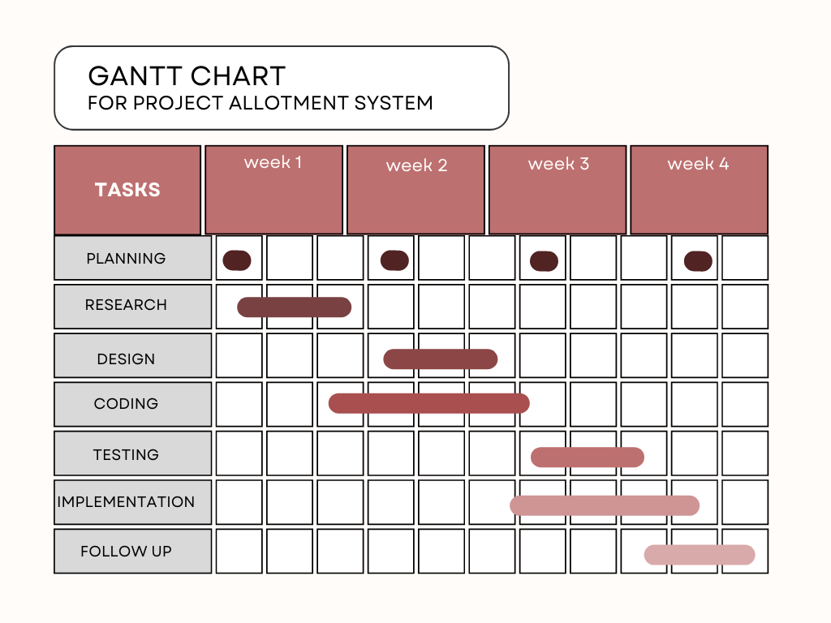

References:

1. Kausalya, J., & Sumathi, P. (2015). A Study on Project Allocation System using Data Mining. International Journal of Computer Applications, 118(13), 1-5.
2. Jafarzadeh, R., & Shahriar, A. R. (2017). An Intelligent Project Allocation System Using Fuzzy Logic and Genetic Algorithm. International Journal of Computer Applications, 160(9), 1-5.
3. Pandey, S. K., & Goyal, S. (2017). Optimization of Project Allocation Process using Multi-Criteria Decision-Making Techniques. International Journal of Computer Applications, 175(11), 1-6.
4. Parthiban, J., & Sridharan, S. (2016). A Hybrid Intelligent System for Project Allocation. International Journal of Computer Applications, 134(11), 1-5.